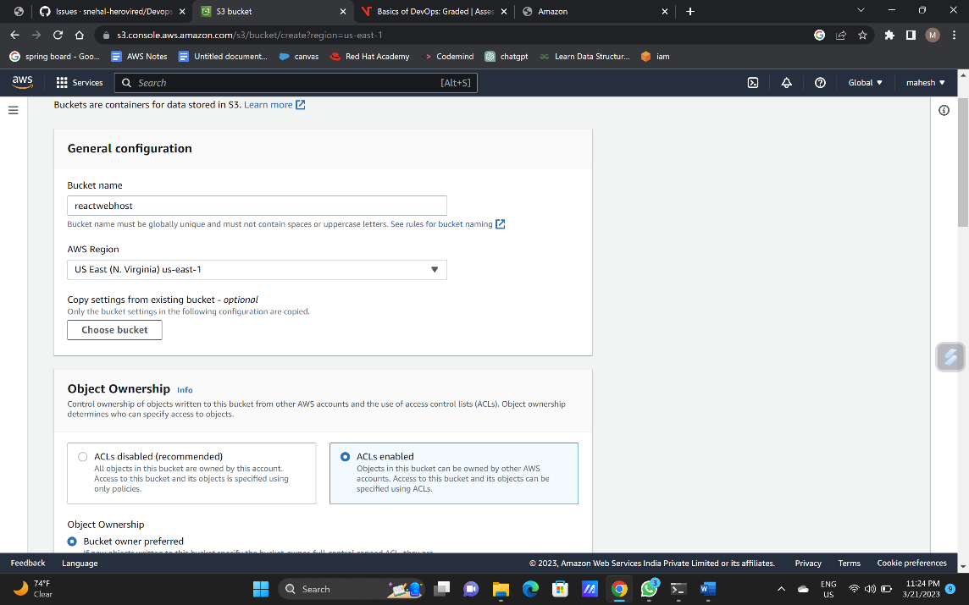Creating the bucket :

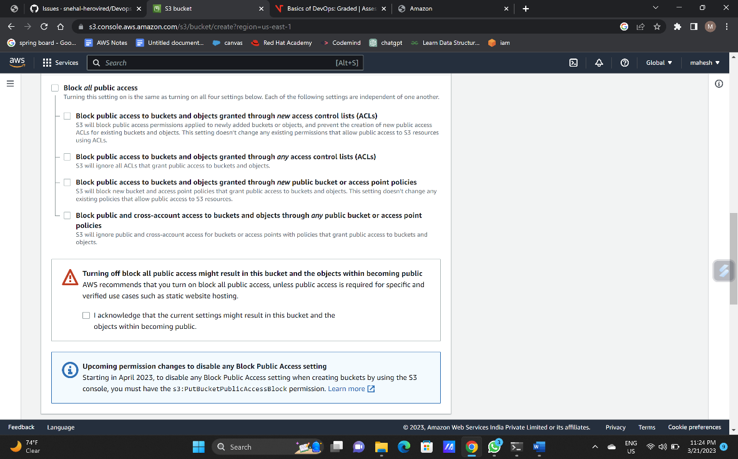

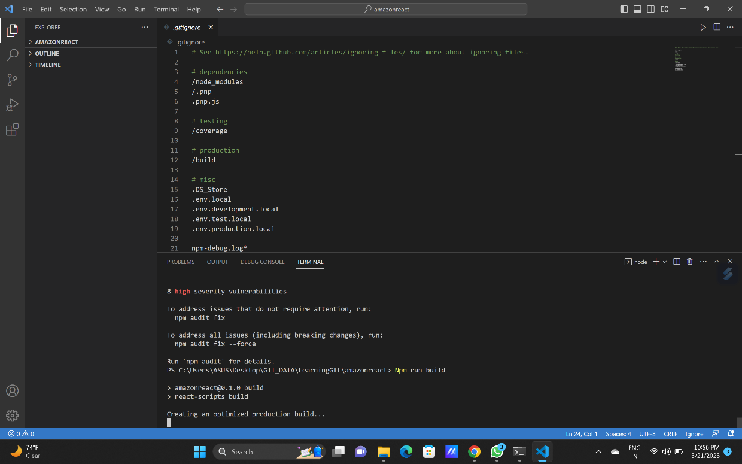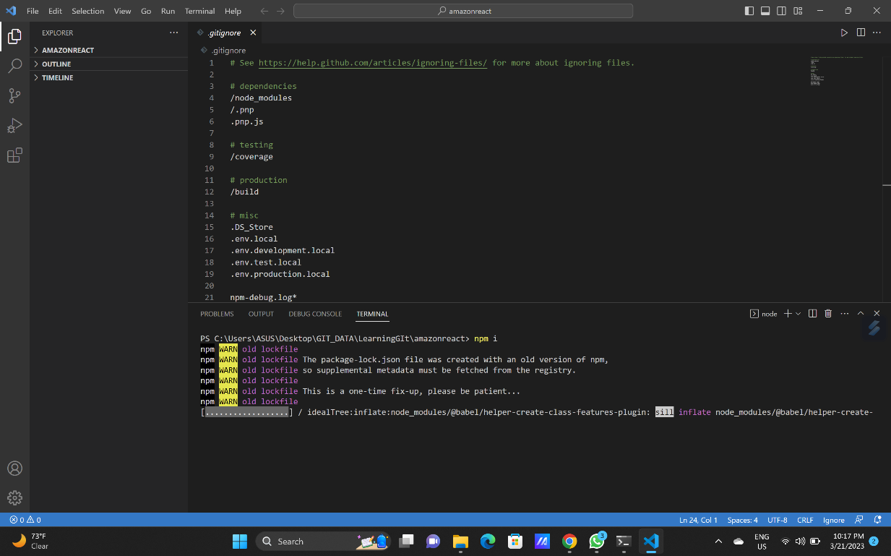use commanns :” Npm I” and “Npm run build” . in the terminal of the vscode.

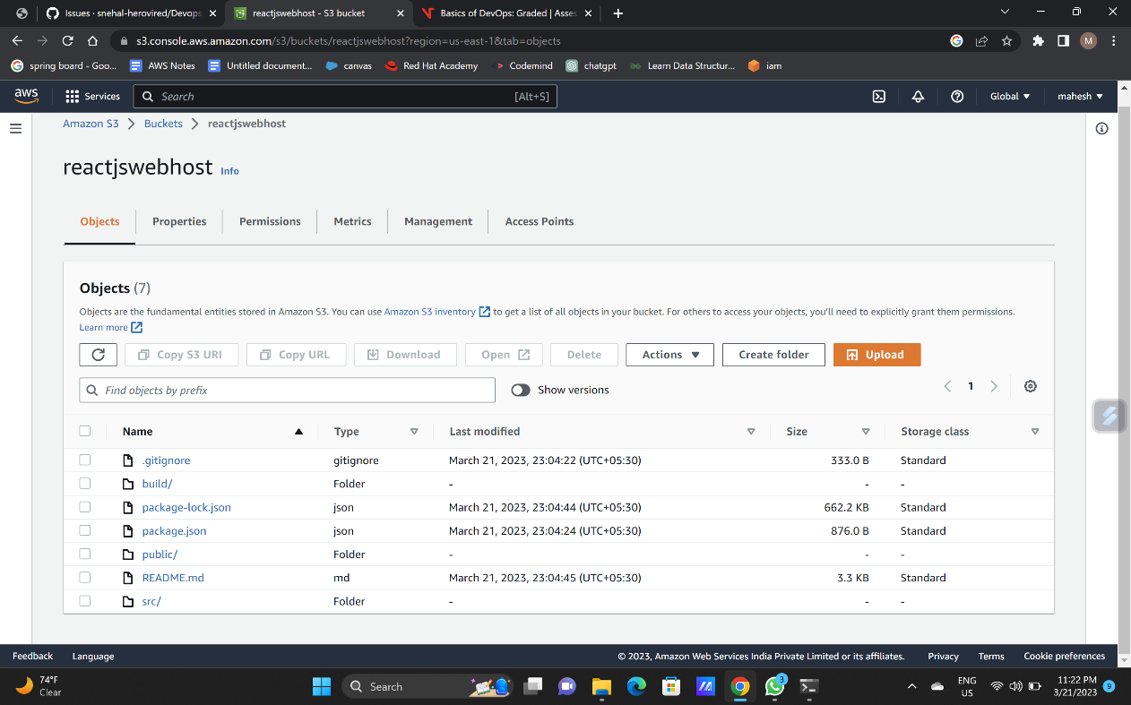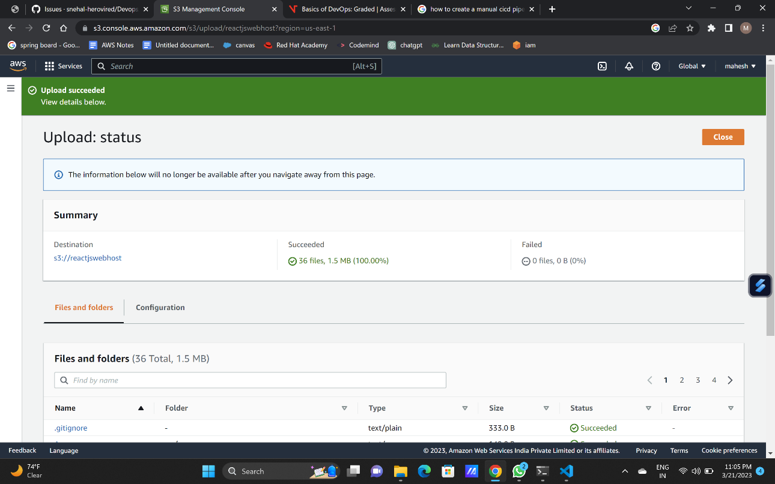Uploading files into the s3 bucket and make it all access by public:

Then copy the object url and paste it in anew tab

Object url : https://reactjswebhost.s3.amazonaws.com/build/index.html

